# Popup Configuration for 2D and 3D Surveys

### General Form

The general form for the definition of a question is:

<question text> {<answer field name>} {<display style>}

With one line per question. If the answer field name and display style are omitted, the configuration line is interpreted instead as a subtitle:

<subtitle text>

### Answer Field Name

This is the case-sensitive name of the field to receive the answer to the question.

### Display Style

This is a case-sensitive style name for the question. Five styles are defined:

* button
* list
* dropdown
* number
* text

The “button”, “list”, and “dropdown” styles require coded-value fields to build their choice display.

The “text” style uses a single-line text-entry display if the question’s field has a length less than 32 characters; otherwise, a multi-line text-entry display is used.

### Inserting Images into Questions

Questions may be supplemented with an image. The image can appear between the question and the answer input (buttons, list, dropdown, text, etc.) or after the answer input.

Between: <question text> {<answer field name>} {image=<image URL>} {<display style>}

After: <question text> {<answer field name>} {<display style>} {image=<image URL>}

### Policy

If the survey form is configured to monitor important/required questions via the “allImportant” policy, the form checks each field to see if it is nullable. If it is nullable, it is considered an optional field; otherwise, it is a required field that must be completed before the form reports that the policy has been satisfied.

### Limitations

The current implementation of the survey form is limited to 31 questions because of the way that it implements the checking of form completion.

### Example

On the following two pages, you will find a sample form (“Appearance” column), the line of text in the popup configuration that defined the form (“Configuration” column), and the definitions of the fields used in the configuration (“Backing Field Definitions” page). It is from the field definition that the question gets the coded values for the “button”, “list”, and “dropdown” styles, the field length for the “text” style, and the nullability of fields.

**Appearance**

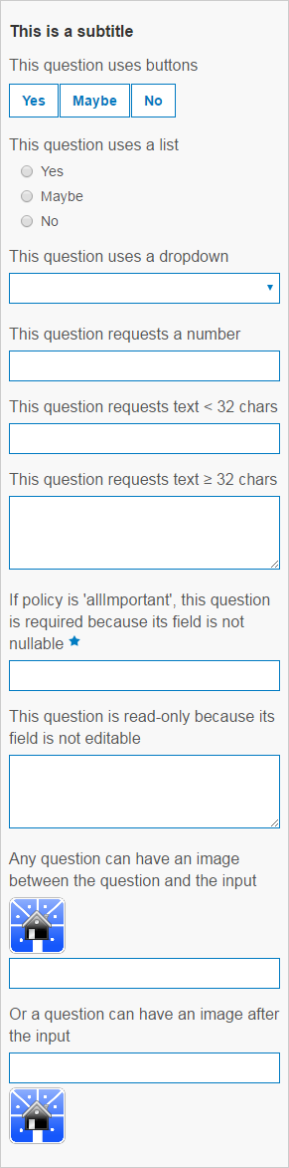

**Configuration**

This is a subtitle

This question uses buttons {question1} {button}

This question uses a list {question2} {list}

This question uses a dropdown {question3} {dropdown}

This question requests a number {question4} {number}

This question requests text < 32 chars {question5} {text}

This question requests text >= 32 chars {question6} {text}

If policy is 'allImportant', this question is required because its field is not nullable {question7} {text}

This question is read-only because its field is not editable {question8} {text}

Any question can have an image between the question and the input {question9} {image=http://tryitlive.arcgis.com/TaxParcelViewer/images/logo.png} {text}

Or a question can have an image after the input {question10} {text} {image=http://tryitlive.arcgis.com/TaxParcelViewer/images/logo.png}

**Backing Field Definitions**

{

"name": "question1",

"type": "esriFieldTypeString",

"alias": "Question #1",

"domain": {

"type": "codedValue",

"name": "YesMaybeNo",

"codedValues": [{

"name": "Yes",

"code": "yes"

}, {

"name": "Maybe",

"code": "maybe"

}, {

"name": "No",

"code": "no"

}]

},

"editable": true,

"nullable": true,

"length": 10

}

{

"name": "question2",

"type": "esriFieldTypeString",

"alias": "Question #2",

"domain": {

"type": "codedValue",

"name": "YesMaybeNo",

"codedValues": [{

"name": "Yes",

"code": "yes"

}, {

"name": "Maybe",

"code": "maybe"

}, {

"name": "No",

"code": "no"

}]

},

"editable": true,

"nullable": true,

"length": 10

}

{

"name": "question3",

"type": "esriFieldTypeString",

"alias": "Question #3",

"domain": {

"type": "codedValue",

"name": "YesMaybeNo",

"codedValues": [{

"name": "Yes",

"code": "yes"

}, {

"name": "Maybe",

"code": "maybe"

}, {

"name": "No",

"code": "no"

}]

},

"editable": true,

"nullable": true,

"length": 10

}

{

"name": "question4",

"type": "esriFieldTypeInteger",

"alias": "Question #4",

"domain": null,

"editable": true,

"nullable": true,

"length": 10

}

{

"name": "question5",

"type": "esriFieldTypeString",

"alias": "Question #5",

"domain": null,

"editable": true,

"nullable": true,

"length": 20

}

{

"name": "question6",

"type": "esriFieldTypeString",

"alias": "Question #6",

"domain": null,

"editable": true,

"nullable": true,

"length": 100

}

{

"name": "question7",

"type": "esriFieldTypeString",

"alias": "Question #7",

"domain": null,

"editable": true,

"nullable": false,

"length": 31

}

{

"name": "question8",

"type": "esriFieldTypeString",

"alias": "Question #8",

"domain": null,

"editable": false,

"nullable": true,

"length": 32

}

{

"name": "question9",

"type": "esriFieldTypeString",

"alias": "Question #9",

"domain": null,

"editable": true,

"nullable": true,

"length": 5

}

{

"name": "question10",

"type": "esriFieldTypeString",

"alias": "Question #10",

"domain": null,

"editable": true,

"nullable": true,

"length": 10

}